**Chapter 5: Network and Communication**

**NETWORKS**

A network is a set of devices (often referred to as *nodes)* connected by communication links. A node can be a computer, printer, or any other device capable of sending and/or receiving data generated by other nodes on the network.

**Network Criteria**

A network must be able to meet a certain number of criteria. The most important of these are performance, reliability, and security.

1. ***Performance***

Performance can be measured in many ways, including transit time and response time. Transit time is the amount of time required for a message to travel from one device to another. Response time is the elapsed time between an inquiry and a response. The performance of a network depends on a number of factors, including the number of users, the type of transmission medium, the capabilities of the connected hardware, and the efficiency of the software. Performance is often evaluated by two networking metrics: throughput and delay. We often need more throughputs and less delay. However, these two criteria are often contradictory. If we try to send more data to the network, we may increase throughput but we increase the delay because of traffic congestion in the network.

1. ***Reliability***

In addition to accuracy of delivery, network reliability is measured by the frequency of failure, the time it takes a link to recover from a failure, and the network's robustness in a catastrophe.

1. ***Security***

Network security issues include protecting data from unauthorized access, protecting data from damage and development, and implementing policies and procedures for recovery from breaches and data losses.

**Data Communication**

Data communications (DC) is the process of using computing and communication technologies to transfer data from one place to another, and vice versa. It enables the movement of electronic or digital data between two or more nodes, regardless of geographical location, technological medium or data contents.

Data communications incorporates several techniques and technologies with the primary objective of enabling any form of electronic communication. These technologies include telecommunications, computer networking and radio/satellite communication. Data communication usually requires existence of a transportation or communication medium between the nodes wanting to communicate with each other, such as copper wire, fiber optic cables or wireless signals.

**Network Topology**

* **Network Topology** refers to layout of a **network**. How different nodes in a **network** are connected to each other and how they communicate is determined by the **network's topology**.
* Topology defines the structure of the network of how all the components are interconnected to each other.
* **Network topology** refers to the physical or logical layout of a **network**.
* There are two **types of network topologies**: physical and logical.
* Physical **topology** emphasizes the physical layout of the connected devices and nodes, while the logical **topology** focuses on the pattern of data transfer between **network** nodes.

**Physical Topology**

* The term *physical topology* refers to the way in which a network is laid out physically
* The topology of a network is the geometric representation of the relationship of all the links and linking devices (usually called nodes) to one another.

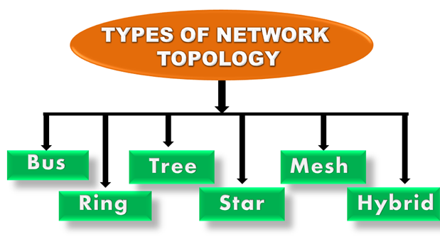

**Bus Topology**

* Bus topology is a network type in which every computer and network device is connected to single cable.
* When a node wants to send a message over the network, it puts a message over the network. All the stations available in the network will receive the message whether it has been addressed or not.
* The configuration of a bus topology is quite simpler as compared to other topologies.
* The most common access method of the bus topologies is **CSMA** (Carrier Sense Multiple Access).

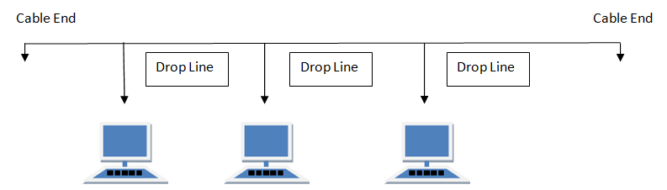

Features of Bus Topology

1. It transmits data only in one direction.
2. Every device is connected to a single cable

Advantages of Bus Topology

1. It is cost effective.
2. Cable required is least compared to other network topology.
3. Used in small networks.
4. It is easy to understand.
5. Easy to expand joining two cables together.

Disadvantages of Bus Topology

1. Cables fails then whole network fails.
2. If network traffic is heavy or nodes are more the performance of the network decreases.
3. Cable has a limited length.
4. It is slower than the ring topology.

## RING Topology

It is called ring topology because it forms a ring as each computer is connected to another computer, with the last one connected to the first.

* Ring topology is like a bus topology, but with connected ends.
* The node that receives the message from the previous computer will retransmit to the next node.
* The data flows in one direction, i.e., it is unidirectional.
* The data flows in a single loop continuously known as an endless loop.
* It has no terminated ends, i.e., each node is connected to other node and having no termination point.
* The data in a ring topology flow in a clockwise direction.
* The most common access method of the ring topology is **token passing**.

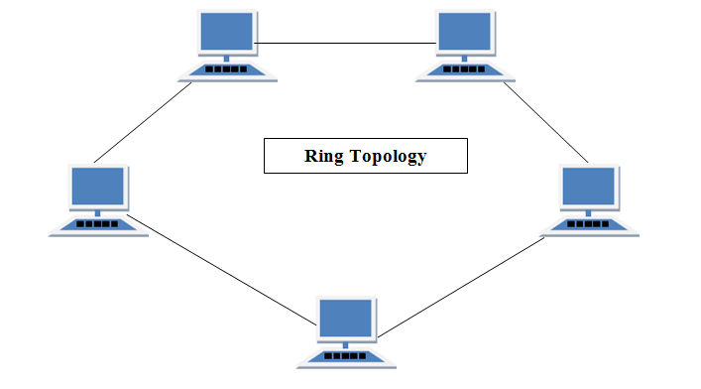

Advantages of Ring Topology

1. Transmitting network is not affected by high traffic or by adding more nodes, as only the nodes having tokens can transmit data.
2. Cheap to install and expand

Disadvantages of Ring Topology

1. Troubleshooting is difficult in ring topology.
2. Adding or deleting the computers disturbs the network activity.
3. Failure of one computer disturbs the whole network

## Star Topology

* Star topology is an arrangement of the network in which every node is connected to the central hub, switch or a central computer.
* The central computer is known as a **server**, and the peripheral devices attached to the server are known as **clients**.
* Coaxial cable or RJ-45 cables are used to connect the computers.
* Hubs or Switches are mainly used as connection devices in a **physical star topology**.
* Star topology is the most popular topology in network implementation.

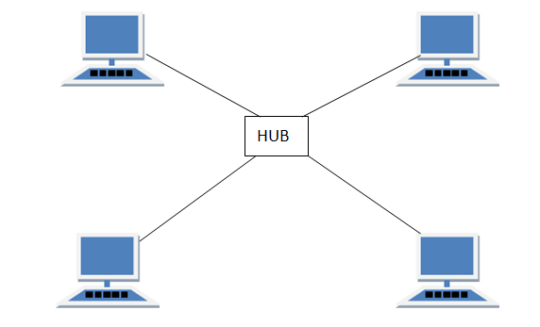

Features of Star Topology

1. Every node has its own dedicated connection to the hub.
2. Hub acts as a repeater for data flow.
3. Can be used with twisted pair, Optical Fibre or coaxial cable.

Advantages of Star Topology

1. Fast performance with few nodes and low network traffic.
2. Hub can be upgraded easily.
3. Easy to troubleshoot.
4. Easy to setup and modify.
5. Only that node is affected which has failed, rest of the nodes can work smoothly.

Disadvantages of Star Topology

1. Cost of installation is high.
2. Expensive to use.
3. If the hub fails then the whole network is stopped because all the nodes depend on the hub.
4. Performance is based on the hub that is it depends on its capacity

## MESH Topology

It is a point-to-point connection to other nodes or devices. All the network nodes are connected to each other. Mesh has n (n-1)/2 physical channels to link n devices.

There are two techniques to transmit data over the Mesh topology, they are:

1. Routing
2. Flooding

### MESH Topology: Routing

In routing, the nodes have a routing logic, as per the network requirements. Like routing logic to direct the data to reach the destination using the shortest distance. Or, routing logic which has information about the broken links, and it avoids those nodes etc. We can even have routing logic, to re-configure the failed nodes.

### MESH Topology: Flooding

In flooding, the same data is transmitted to all the network nodes, hence no routing logic is required. The network is robust, and the its very unlikely to lose the data. But it leads to unwanted load over the network.

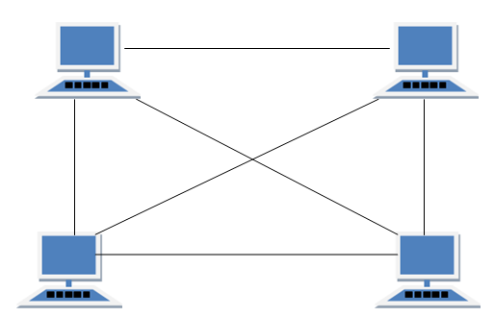

Features of Mesh Topology

1. Fully connected.
2. Robust.
3. Not flexible.

Advantages of Mesh Topology

1. Each connection can carry its own data load.
2. It is robust.
3. Fault is diagnosed easily.
4. Provides security and privacy.

Disadvantages of Mesh Topology

1. Installation and configuration is difficult.
2. Cabling cost is more.
3. Bulk wiring is required.

## TREE Topology

* A tree topology is a type of structure in which all the computers are connected with each other in hierarchical fashion.
* The top-most node in tree topology is known as a root node, and all other nodes are the descendants of the root node.
* There is only one path exists between two nodes for the data transmission. Thus, it forms a parent-child hierarchy.

Features of Tree Topology

1. Ideal if workstations are located in groups.
2. Used in Wide Area Network.

Advantages of Tree Topology

1. Extension of bus and star topologies.
2. Expansion of nodes is possible and easy.
3. Easily managed and maintained.
4. Error detection is easily done.

Disadvantages of Tree Topology

1. Heavily cabled.
2. Costly.
3. If more nodes are added maintenance is difficult.
4. Central hub fails, network fails.

## HYBRID Topology

* The combination of various different topologies is known as **Hybrid topology**.
* A Hybrid topology is a connection between different links and nodes to transfer the data.
* When two or more different topologies are combined together is termed as Hybrid topology and if similar topologies are connected with each other will not result in Hybrid topology. For example, if there exist a ring topology in one branch of ICICI bank and bus topology in another branch of ICICI bank, connecting these two topologies will result in Hybrid topology.

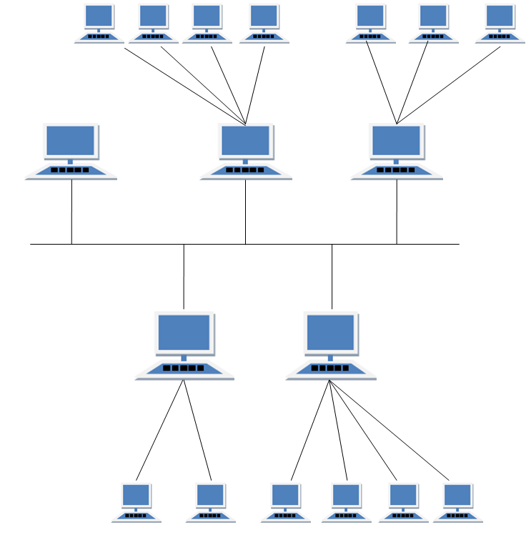

Features of Hybrid Topology

1. It is a combination of two or topologies
2. Inherits the advantages and disadvantages of the topologies included

Advantages of Hybrid Topology

1. Reliable as Error detecting and trouble shooting is easy.
2. Effective.
3. Scalable as size can be increased easily.
4. Flexible.

Disadvantages of Hybrid Topology

1. Complex in design.
2. Costly.

# Categories of Networks (Types of Communication Networks)

## LAN(Local Area Network)

* Local Area Network is a group of computers connected to each other in a small area such as building, office.
* LAN is used for connecting two or more personal computers through a communication medium such as twisted pair, coaxial cable, etc.
* It is less costly as it is built with inexpensive hardware such as hubs, network adapters, and ethernet cables.
* The data is transferred at an extremely faster rate in Local Area Network.
* Local Area Network provides higher security.
* LAN can be a simple network like connecting two computers, to share files and network among each other while it can also be as complex as interconnecting an entire building.
* LAN networks are also widely used to share resources like printers, shared hard-drive etc.
* can use different types of topologies through LAN, these are Star, Ring, Bus, Tree etc

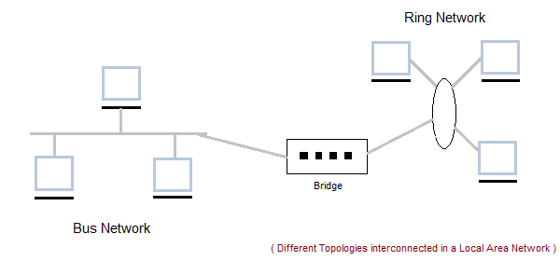

### Characteristics of LAN

* LAN's are private networks, not subject to tariffs or other regulatory controls.
* LAN's operate at relatively high speed when compared to the typical WAN.
* There are different types of Media Access Control methods in a LAN, the prominent ones are Ethernet, Token ring.
* It connects computers in a single building, block or campus, i.e. they work in a restricted geographical area.

### Advantages of LAN

* **Resource Sharing:** Computer resources like printers, modems, DVD-ROM drives and hard disks can be shared with the help of local area networks. This reduces cost and hardware purchases.
* **Software Applications Sharing:** It is cheaper to use same software over network instead of purchasing separate licensed software for each client a network.
* **Easy and Cheap Communication:** Data and messages can easily be transferred over networked computers.
* **Centralized Data:** The data of all network users can be saved on hard disk of the server computer. This will help users to use any workstation in a network to access their data. Because data is not stored on workstations locally.
* **Data Security:** Since, data is stored on server computer centrally, it will be easy to manage data at only one place and the data will be more secure too.
* **Internet Sharing:** Local Area Network provides the facility to share a single internet connection among all the LAN users. In Net Cafes, single internet connection sharing system keeps the internet expenses cheaper.

### Disadvantages of LAN

* **High Setup Cost:** Although the LAN will save cost over time due to shared computer resources, but the initial setup costs of installing Local Area Networks is high.
* **Privacy Violations:** The LAN administrator has the rights to check personal data files of each and every LAN user. Moreover he can check the internet history and computer use history of the LAN user.
* **Data Security Threat:** Unauthorized users can access important data of an organization if centralized data repository is not secured properly by the LAN administrator.
* **LAN Maintenance Job:** Local Area Network requires a LAN Administrator because, there are problems of software installations or hardware failures or cable disturbances in Local Area Network. A LAN Administrator is needed at this full time job.
* **Covers Limited Area:** Local Area Network covers a small area like one office, one building or a group of nearby buildings.

## ii. MAN (Metropolitan Area Network)

* A metropolitan area network is a network that covers a larger geographic area by interconnecting a different LAN to form a larger network.
* Government agencies use MAN to connect to the citizens and private industries.
* In MAN, various LANs are connected to each other through a telephone exchange line.
* The most widely used protocols in MAN are RS-232, Frame Relay, ATM, ISDN, OC-3, ADSL, etc.
* It has a higher range than Local Area Network (LAN).

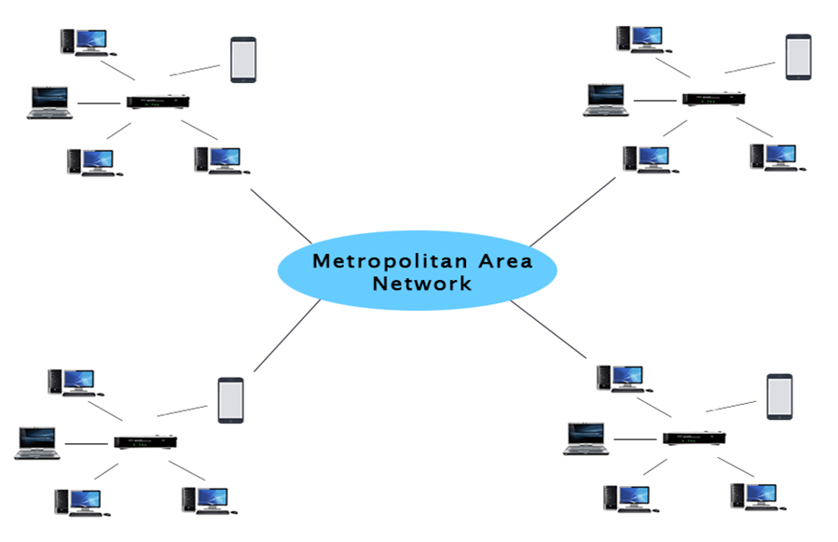

### Characteristics of MAN

* It generally covers towns and cities (50 km)
* Communication medium used for MAN are optical fibers, cables etc.
* Data rates adequate for distributed computing applications.

### Advantages of MAN

* Extremely efficient and provide fast communication via high-speed carriers, such as fibre optic cables.
* It provides a good back bone for large network and provides greater access to WANs.
* The dual bus used in MAN helps the transmission of data in both directions simultaneously.
* A MAN usually encompasses several blocks of a city or an entire city.

### Disadvantages of MAN

* More cable required for a MAN connection from one place to another.
* It is difficult to make the system secure from hackers and industrial espionage (spying) graphical regions.

## WAN (Wide Area Network)

* A Wide Area Network is a network that extends over a large geographical area such as states or countries.
* A Wide Area Network is quite bigger network than the LAN.
* A Wide Area Network is not limited to a single location, but it spans over a large geographical area through a telephone line, fiber optic cable or satellite links.
* The internet is one of the biggest WAN in the world.
* A Wide Area Network is widely used in the field of Business, government, and education.

### Characteristics of WAN

* It generally covers large distances (states, countries, continents).
* Communication medium used are satellite, public telephone networks which are connected by routers.

### Advantages of WAN

* Covers a large geographical area so long distance business can connect on the one network.
* Shares software and resources with connecting workstations.
* Messages can be sent very quickly to anyone else on the network. These messages can have picture, sounds or data included with them(called attachments).
* Expensive things(such as printers or phone lines to the internet) can be shared by all the computers on the network without having to buy a different peripheral for each computer.
* Everyone on the network can use the same data. This avoids problems where some users may have older information than others.

### Disadvantages of WAN

* Need a good firewall to restrict outsiders from entering and disrupting the network.
* Setting up a network can be an expensive, slow and complicated. The bigger the network the more expensive it is.
* Once set up, maintaining a network is a full-time job which requires network supervisors and technicians to be employed.
* Security is a real issue when many different people have the ability to use information from other computers. Protection against hackers and viruses adds more complexity and expense.

## PAN (Personal Area Network)

* Personal Area Network is a network arranged within an individual person, typically within a range of 10 meters.
* Personal Area Network is used for connecting the computer devices of personal use is known as Personal Area Network.
* **Thomas Zimmerman** was the first research scientist to bring the idea of the Personal Area Network.
* Personal Area Network covers an area of **30 feet**.
* Personal computer devices that are used to develop the personal area network are the laptop, mobile phones, media player and play stations.

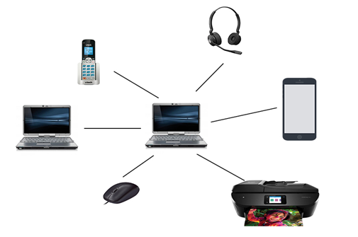

Communication Media or Transmission medium

* Transmission media is a communication channel that carries the information from the sender to the receiver. Data is transmitted through the electromagnetic signals.
* The main functionality of the transmission media is to carry the information in the form of bits through **LAN**(Local Area Network).
* It is a physical path between transmitter and receiver in data communication.
* The transmission medium is usually free space, metallic cable, or fiber-optic cable
* Transmission media can be divided into two broad categories: guided and unguided.

**GUIDED MEDIA**

Guided media, which are those that provide a conduit from one device to another, include twisted-pair cable, coaxial cable, and fiber-optic cable. A signal traveling along any of these media is directed and contained by the physical limits of the medium.

It is defined as the physical medium through which the signals are transmitted. It is also known as Bounded media.

Twisted-Pair Cable

A twisted pair consists of two conductors (normally copper), each with its own plastic insulation, twisted together.

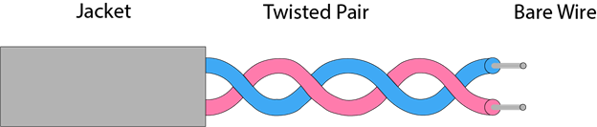

* The degree of reduction in noise interference is determined by the number of turns per foot.
* Increasing the number of turns per foot decreases noise interference.
* Twisted-pair cables are used in telephone lines to provide voice and data channels.

## Coaxial Cable

* Coaxial cable is very commonly used transmission media, for example, TV wire is usually a coaxial cable.
* The name of the cable is coaxial as it contains two conductors parallel to each other.

Coaxial cable (or *coax)* carries signals of higher frequency ranges than those in twisted pair cable. Instead of having two wires, coax has a central core conductor of solid or stranded wire (usually copper) enclosed in an insulating sheath, which is, in turn, encased in an outer conductor of metal foil, braid, or a combination of the two.

The outer metallic wrapping serves both as a shield against noise and as the second conductor, which completes the circuit. This outer conductor is also enclosed in an insulating sheath, and the whole cable is protected by a plastic cover

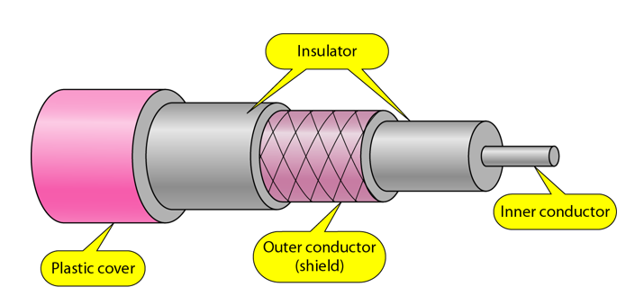

**Advantages of Coaxial cable:**

* The data can be transmitted at high speed.
* It has better shielding as compared to twisted pair cable.
* It provides higher bandwidth.

**Disadvantages of Coaxial cable:**

* It is more expensive as compared to twisted pair cable.
* If any fault occurs in the cable causes the failure in the entire network.

**Optical Fiber**

* A fiber-optic cable is made of glass or plastic and transmits signals in the form of light.
* An optical fiber cable is a type of cable that has a number of optical fibers bundled together, which are normally covered in their individual protective plastic covers.
* Optical cables are used to transfer digital data signals in the form of light up to distances of hundreds of miles with higher throughput rates than those achievable via electrical communication cables.
* All optical fibers use a core of hair-like transparent silicon covered with less refractive indexed cladding to avoid light leakage to the surroundings. Due to the extreme sensitivity of the optical fiber, it is normally covered with a high-strength, lightweight protective material likes Kevlar.

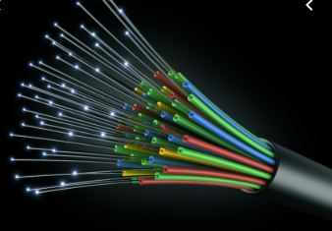

**Following are the advantages of fibre optic cable over copper:**

* **Greater Bandwidth:** The fibre optic cable provides more bandwidth as compared copper. Therefore, the fibre optic carries more data as compared to copper cable.
* **Faster speed:** Fibre optic cable carries the data in the form of light. This allows the fibre optic cable to carry the signals at a higher speed.
* **Longer distances:** The fibre optic cable carries the data at a longer distance as compared to copper cable.
* **Better reliability:** The fibre optic cable is more reliable than the copper cable as it is immune to any temperature changes while it can cause obstruct in the connectivity of copper cable.
* **Thinner and Sturdier:** Fibre optic cable is thinner and lighter in weight so it can withstand more pull pressure than copper cable.

**Network Protocol**

A protocol is a set of rules that govern data communications. A protocol defines what is communicated, how it is communicated, and when it is communicated. The key elements of a protocol are syntax, semantics, and timing.

* Syntax. The term *syntax* refers to the structure or format of the data, meaning the order in which they are presented. For example, a simple protocol might expect the first 8 bits of data to be the address of the sender, the second 8 bits to be the address of the receiver, and the rest of the stream to be the message itself.
* Semantics. The word *semantics* refers to the meaning of each section of bits. How is a particular pattern to be interpreted, and what action is to be taken based on that interpretation? For example, does an address identify the route to be taken or the final destination of the message?
* Timing. The term *timing* refers to two characteristics: when data should be sent and how fast they can be sent. For example, if a sender produces data at 100 Mbps but the receiver can process data at only 1 Mbps, the transmission will overload the receiver and some data will be lost.

**TCP/IP protocol**

**Transmission control protocol/Internet protocol**, **TCP/IP** is a set of rules ([protocols](https://www.computerhope.com/jargon/p/protocol.htm)) governing communications among all computers on the Internet.

The Transmission Control Protocol is responsible for ensuring the reliable transmission of data across Internet-connected networks. TCP checks packets for errors and submits requests for re-transmissions if any are found.

There are four total layers of TCP/IP protocol, listed below with a brief description.

* **Network Access Layer** - This layer is concerned with building [packets](https://www.computerhope.com/jargon/p/packet.htm).
* **Internet Layer** - This layer uses [IP](https://www.computerhope.com/jargon/i/ip.htm) (Internet Protocol) to describe how packets are to be delivered.
* **Transport Layer** - This layer utilizes [UDP](https://www.computerhope.com/jargon/u/udp.htm) (User Datagram Protocol) and [TCP](https://www.computerhope.com/jargon/t/tcp.htm) (Transmission Control Protocol) to ensure the proper transmission of data.
* **Application Layer** - This layer deals with application network processes. These processes include [FTP](https://www.computerhope.com/jargon/f/ftp.htm) (File Transfer Protocol), [HTTP](https://www.computerhope.com/jargon/h/http.htm) (Hypertext Transfer Protocol), and [SMTP](https://www.computerhope.com/jargon/s/smtp.htm) (Simple Mail Transfer Protocol).